ROZKŁAD MATERIAŁU – 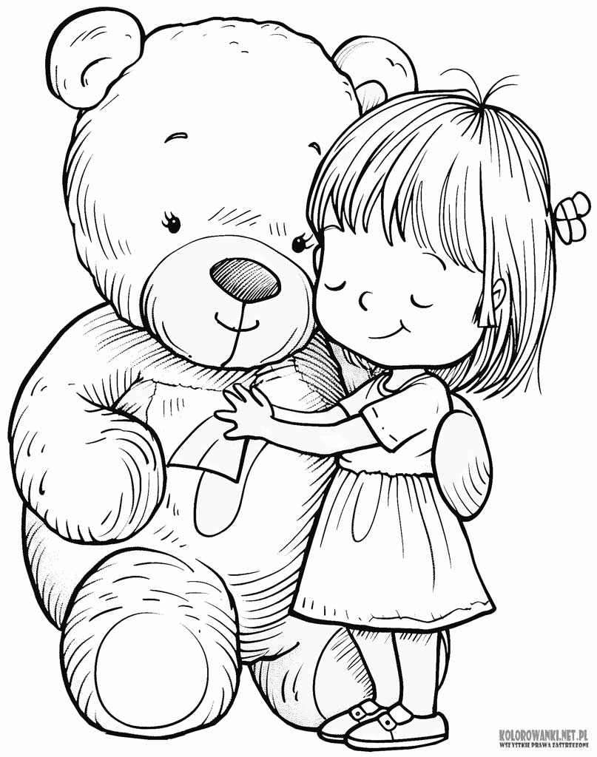

J.ANGIELSKI-

WRZESIEŃ DLA 6 - LATKÓW

**BIG REVISION- duża powtórka !!!**

* Our songs: *"Hello song", "Goodbye song", "Hello-can you clap your hands?", "Bye, bye- see you next time", “Head and Shoulders” "What's your name?", "Color song- I see something...blue", "Time to make a circle"*, "Wake up Teddy- knock, knock, knock...", "How are you today?-happy, sad, hungry", *Twinkle Twinkle Little Star", "Finger Family Collection- Family song/ Daddy Finger"*
* *What's your name?/ My name is... nice to meet you or I am...-And You?, Yes/ No*
* *Good friends: computer, hot-dog, hamburger, radio, telephone.*
* *"Quiet please, come here, listen, look, stand up, sit down, turn around, jump"* ,*"What is this?- This is..."- “co to jest?- to jest…”*
* *RAINBOW*- tęcza/ kolory: *blue, yellow, red, purple, pink, orange, brown, green, white, black/ "What color is it?- It's..."- “jaki to kolor?”*
* *Toys: doll, ball, teddy bear, kite, train, car, bike, boat*
* *We can count 1-10*
* *Animals*: cat, dog, elephant, monkey, giraffe, tiger, cow, duck, pig, lion, crocodile/ *big*- duży, *small*- mały.
* *Fruits*: an orange, banana, an apple, pear, plum, grapes, cherries, strawberry etc.
* *I LIKE...*- ja lubię...
* *My Family*: mum, dad, baby, grandma, grandpa, brother
* VEGETABLES: potato, carrot, cucumber, tomato
* *Body Parts*: HEAD, SHOULDER, KNEE, TOE, EYE, EAR, MOUTH, NOSE, LEG, NECK, CHIN, FINGER, HAND, FOOT, FACE, HAIR, STOMACH, BACK
* **AUTUMN**- jesień,**IN THE FOREST**- w lesie**/ LEAF-** liść**, CONKER-** kasztan, **SQUIRREL**- wiewiórka**, MUSHROOMS**- grzyby, Autumn weather-is it warm or cold outside?
* **It’s raining, it’s windy, it’s cloudy**

*…*

* przy pomocy wspólnej zabawy, kolorowych obrazków, tzw. flashcards oraz śpiewu utrwalamy w. w. formy j. angielskiego.

**Poznajemy wierszyk**:

**"Good morning, good morning,**

**do you want to play with me?**

**so, let's play in english**

**it' easy-you will see"**